In order to install Ubuntus OS, we have to create another VM:
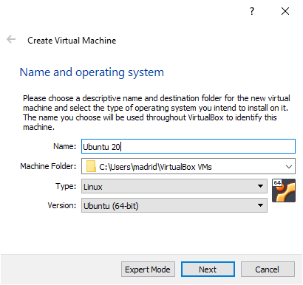

With the following settings:

2 GB:
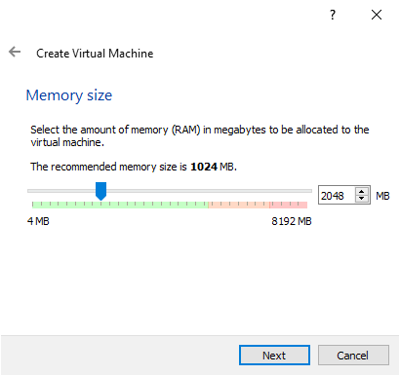

30 GB Hard disck:
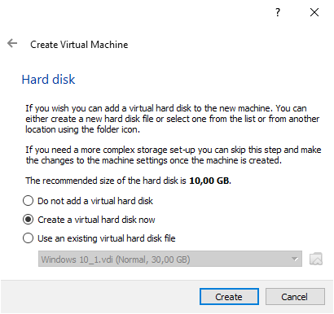
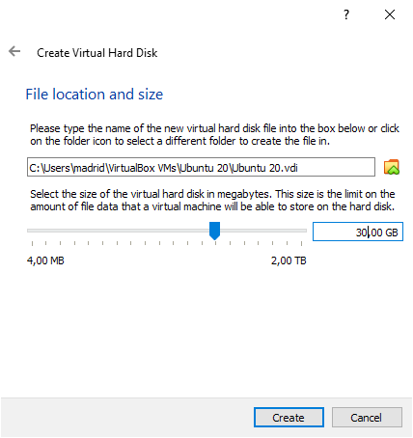

Go to you virtual machine and with the machine off, you select the option Shared Folders, then the icon with a folder an a plus (+) green symbol, a new window will pop up, on Folder Path you will be able to select the new folder that you create on you real machine:

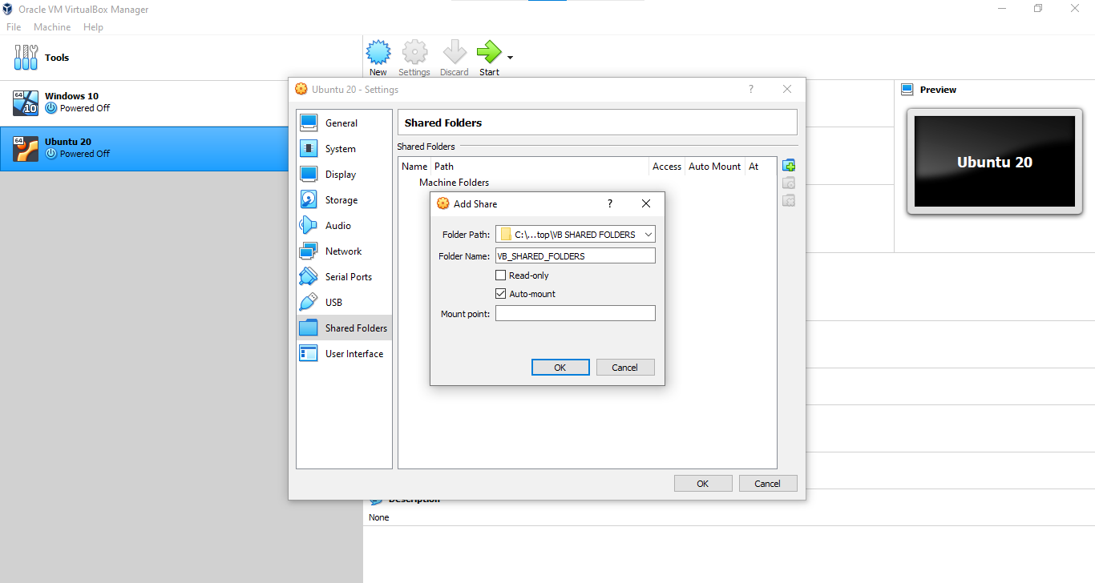

Now, we need to allow an Internet connection including acces to the rest of machines in the network, so you will go to General settings, Advanced and in the options Shared Clipboard and Drag´n Drop you choose Bidirectional for both, then OK:
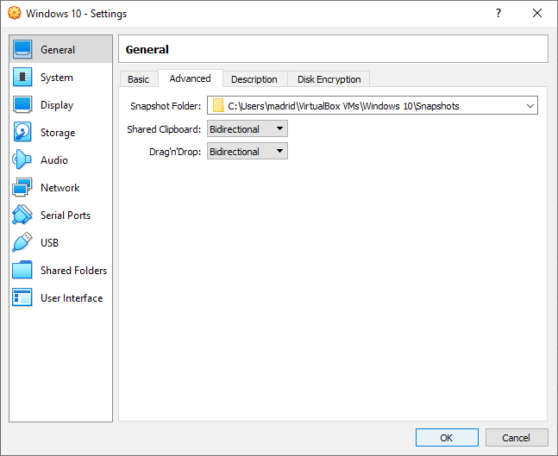

Then on the network menu, be shure that the option Enable Network Adapter is chosen, then on Attached to, select Bridged Adapter, the name of the Network will show by default, then select OK:
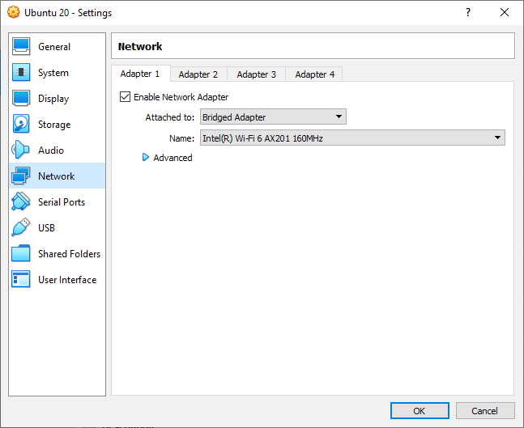

Install Ubuntu 20 in the virtual machine.

You must chose the Option Settings, then Storage, the empty storage unit and finally click on the CD icon and chose Select Hard disk file:
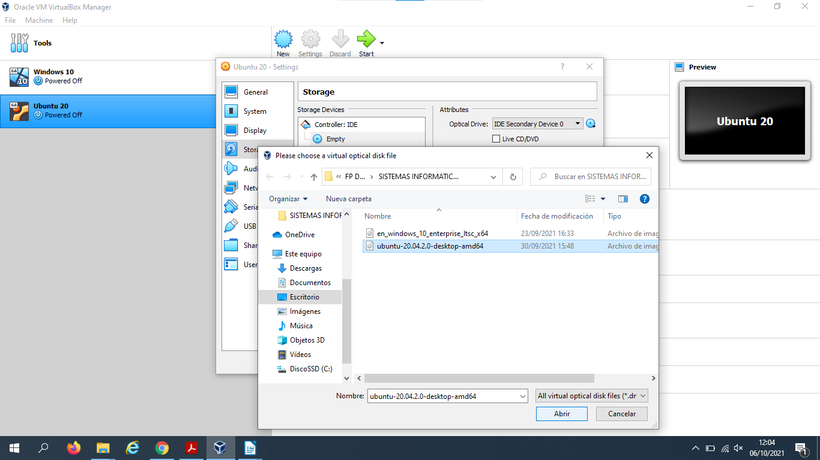

You screen will show you the Ubuntus’s set up, you select Install Ubuntu:
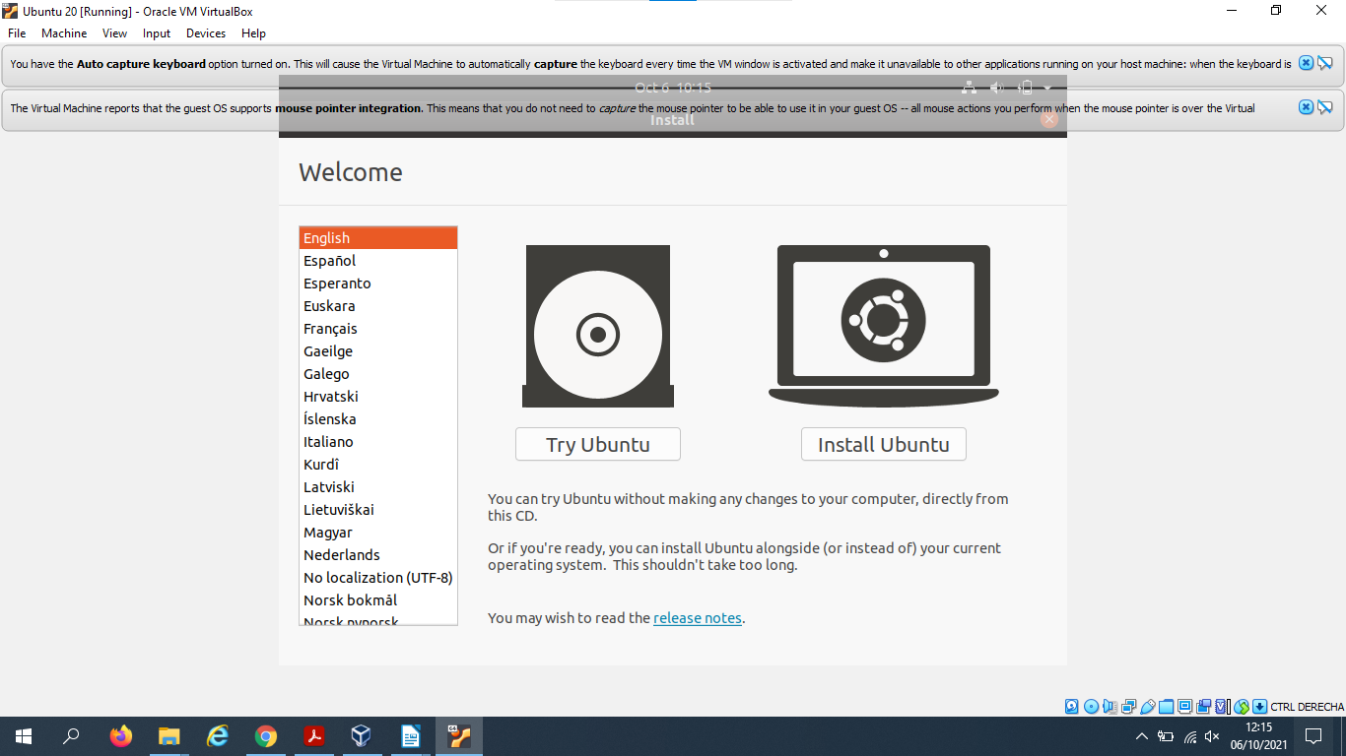

The software ask you about the settings you would like to install:
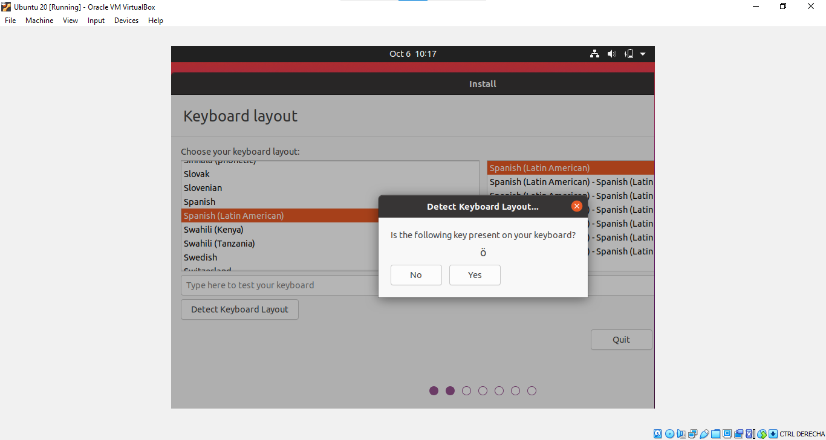

Here, you will choose Normal Installation:
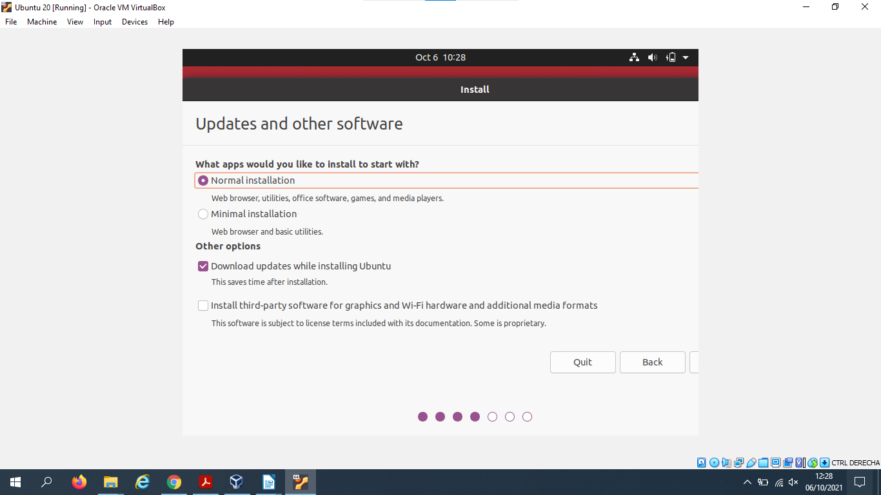

In our case the disck is empty, so you select Erase Disck and install Ubuntus. You can choose too the option Something Else and select the different partitions:
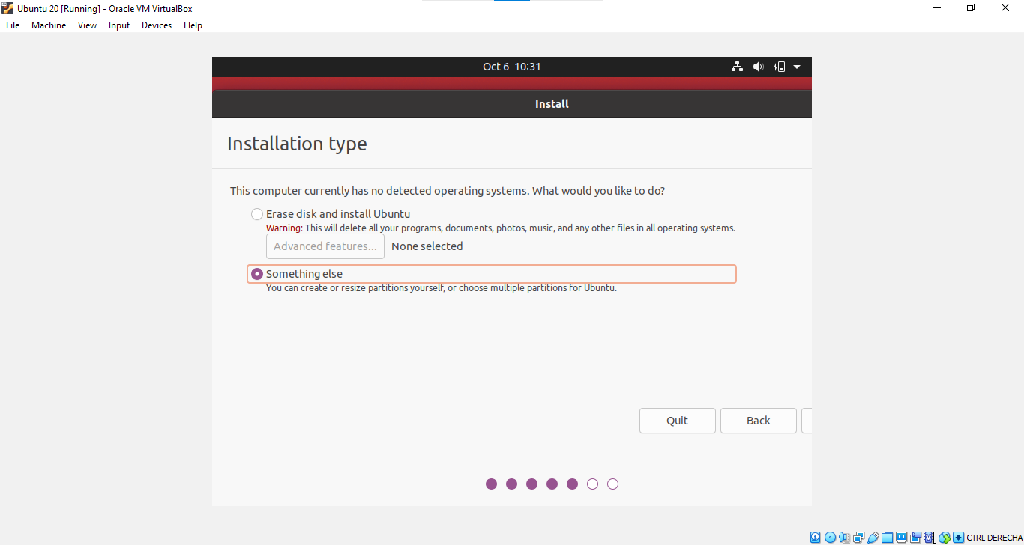

The software show on the screen your current location:
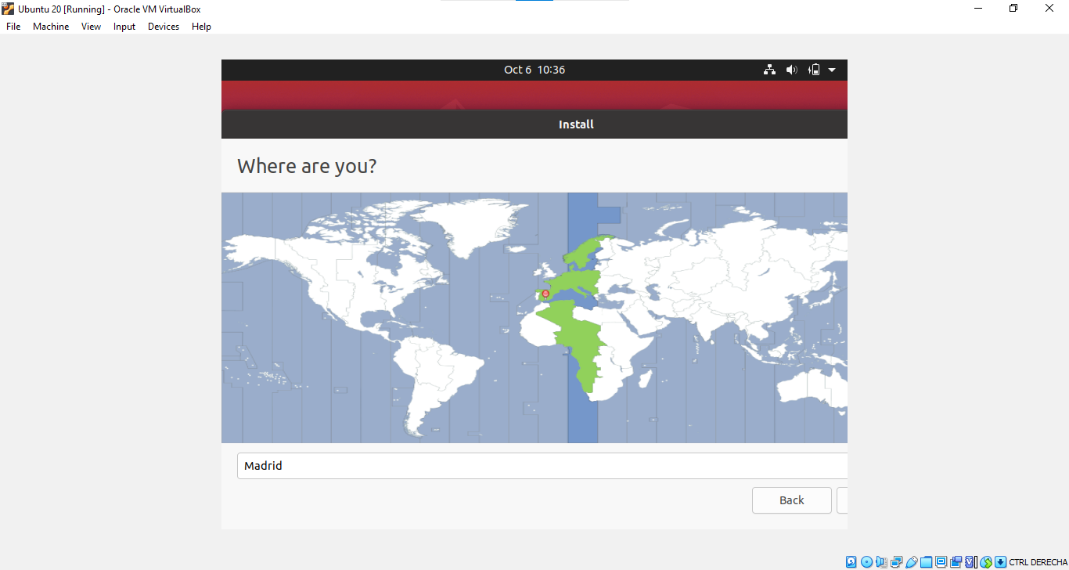

The installation of Ubuntus begins:
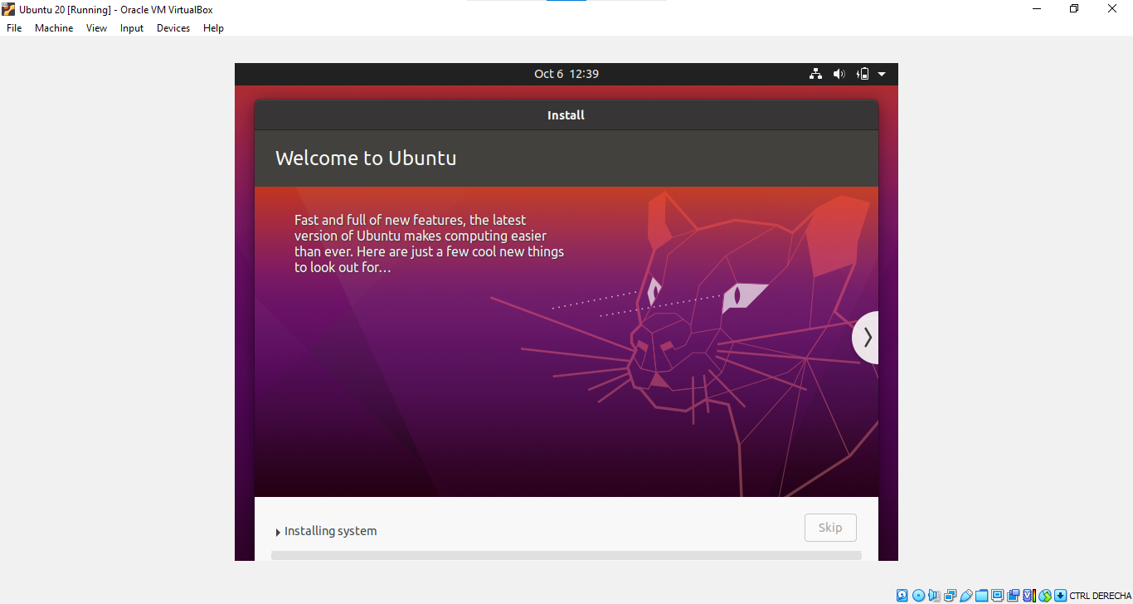

In this case, the software aware you about a new version, I choose to installing it so the software ask me for the password:
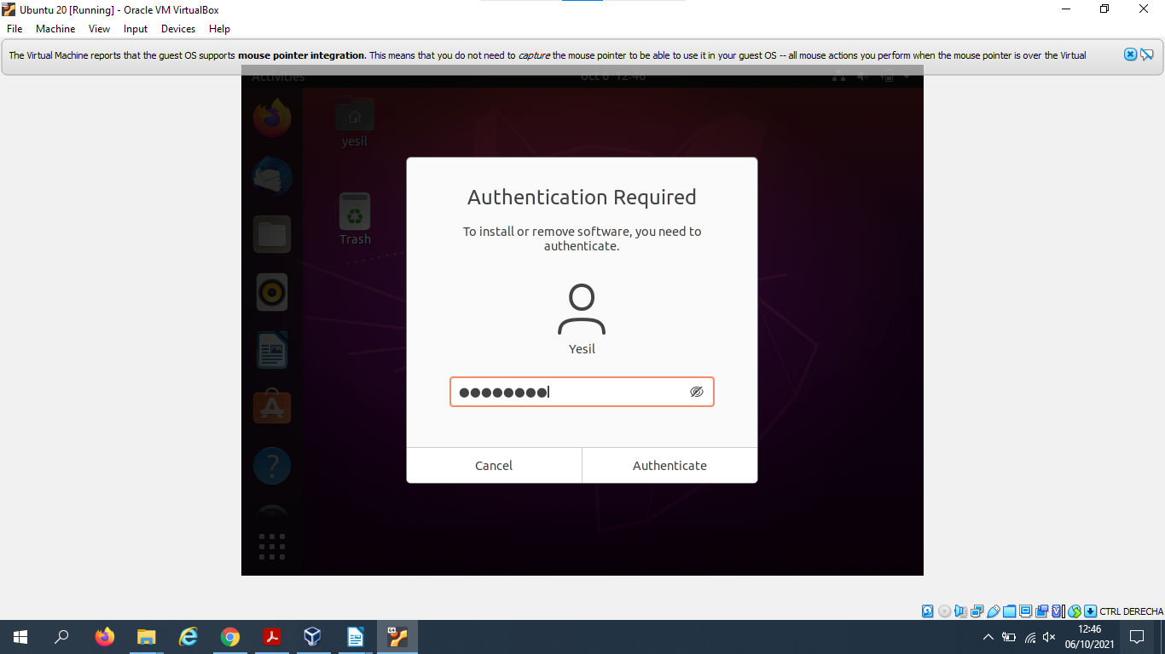

And finally, Linux is done.

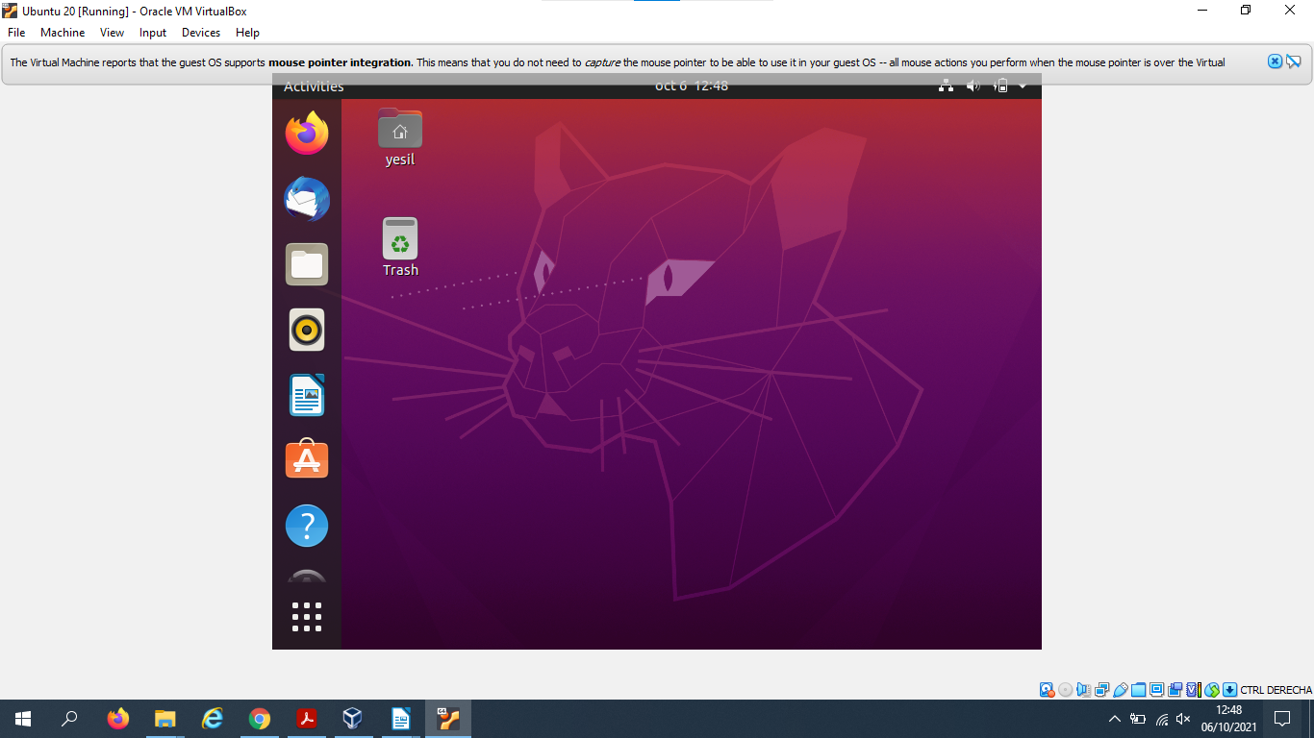

jgtjgjtjgt

